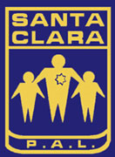
Santa Clara Police Activities League
Youth Bowling
League begins on Saturday, July 12th ; Ends on September 13, 2014

Summer League Now Forming!

Au
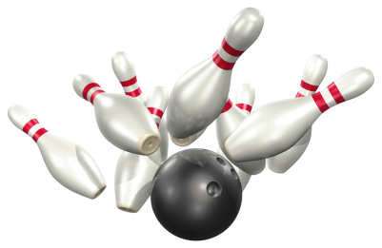
Saturdays in the Summer at 11 a.m.
AMF Moonlite Lanes in Santa Clara
Sign-up as a team or individual; individuals will be placed on teams! Note: trophies may be optional for low enrollment.
Note: If there are not enough kids to make a team, we will still have Bowling lessons & weekly prizes for highest score. Sign-up with a friend and earn a free game.
Sign-up Events at the Santa Clara P.A.L. office: SCPD, 601 El Camino Real (M-F) 1-5 pm Or
Last Day to Sign-up: Friday, Jul 11th
At Santa Clara AMF Moonlite Lanes:
2780 El Camino Real (near Kiely)
Last day to Bowl: September 13th
For more information, please call PAL Office or Officer Rob Martinez at (408) 615-4880 or nhelvie@santaclaraca.gov or fax to: 408.984.1407
Scholarships available!
New Sign-up and League Fee:
$25 per person plus fees above; Family discount: 2 for $40; 3 for $55 (plus cost of each game). If you refer a friend to join, you will receive one free game.
- T-shirt for each bowler
- One-on-one coaching (limited availability)
- Free Shoe Rental
- 20% off food and drinks
- Certificate of achievement
- Pizza & soda on last day
Juniors
Ages 13 to 18
5 person teams
3 games each
$7 per person per week
Preps
Ages 9 to 12
4 person teams
3 games each
$7 per person per week
Bantams
Ages 7 to 8
2 person teams
2 persons each
$7 per person per week

