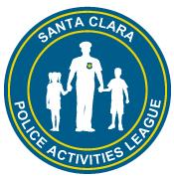
Santa Clara Police Activities League
Youth Bowling
2017 January League Now Forming!

Au
League begins on Saturday, January 7, 2017

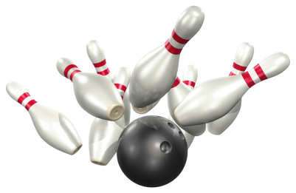
Saturdays in the late Winter-Spring at 11 a.m.
AMF Moonlite Lanes in Santa Clara
Sign-up as a team or individual; individuals will be placed on teams!
Fun bowling lessons, recreational games & individual awards (Mar.4th). Sign-up with a new referral and earn a free game. Coaches needed.
For more info: santaclarapal.org
Sign-up and League Fees: $88/pp or Family w/2 siblings: $83/pp or 3 or more siblings: $81/pp. If you refer a friend to join, you will receive one free game.
- T-shirt for each bowler ( may be given on last day)
- One-on-one coaching (limited availability)
- Free Shoe Rental
- 20% off food and drinks
- Trophies or Jr. certificate of achievement on last day
- Pizza & soda on last day
- Please make checks payable to: SC PAL, (MC/VI/Discover/Cash available as FOP to PAL Office)

Ma

Sign-up at the Santa Clara P.A.L. Office/SCPD,
601 El Camino Real (M-F) 1-6 pm Or
Last Day to Sign-up: Saturday, Jan. 7th at 10:45 a.m.
At Santa Clara AMF Moonlite Lanes:
2780 El Camino Real (near Kiely)
Last day to Bowl: March 4, 2017
Reserve your spot, please call PAL Office @ (408) 615-4879; nhelvie@santaclaraca.gov or fax: 408.984.1407

Juniors
Ages 13 to 18
2-3 person teams
3 games each
$7 per person per week
Preps
Ages 9 to 12
2-3 person teams
3 games each
$7 per person per week
Bantams
Ages 5 to 8
2 person teams
2 games each
$7 per person per week

