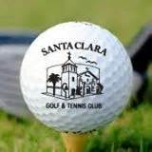
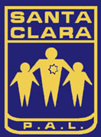
Save the Date!

THE 38th ANNUAL
SANTA CLARA P.A.L. GOLF TOURNAMENT

This will be the last time this will be at

The Santa Clara Golf & Tennis Club, 5151 Stars and Stripes Dr.
Near the Santa Clara Convention Center & Levi Stadium

FRIDAY, AUGUST 21, 2015
10:00am Check-In ♦ 11:00am Lunch ♦ 12:30pm Shotgun Start
6:00pm Dinner – David’s Restaurant

FORMAT: 4 Person Scramble
Limited to the First 160 Entries

ENTRY FEE: $195 Per Person / $780 per foursome

Sign-up early to insure your spot!

Make Checks Payable to: Santa Clara P.A.L.
Santa Clara Police Activities League, 601 El Camino Real, Santa Clara, CA 95050

For information please contact: Santa Clara P.A.L. Office (408) 615-4879

ENTRY FEE INCLUDES:
♣ Golf/Cart ♣ Tee Prizes
♣ Lunch ♣ Door Prizes
♣ Dinner ♣ Longest Drive Trophy
♣ Refreshments on the Course ♣ Closest to the Pin Trophy
♣ High/Low Gross Team Awards ♣ Hole-in-One Prize

SPONSORSHIPS AVAILABLE

The Tournament Committee
wishes to thank you for your support.

For details, registration, sponsorship forms & special guest information,
go to www.santaclarapal.org or call: (408) 615-4880

